ANALYSE OF REDDIT 2014-01-07

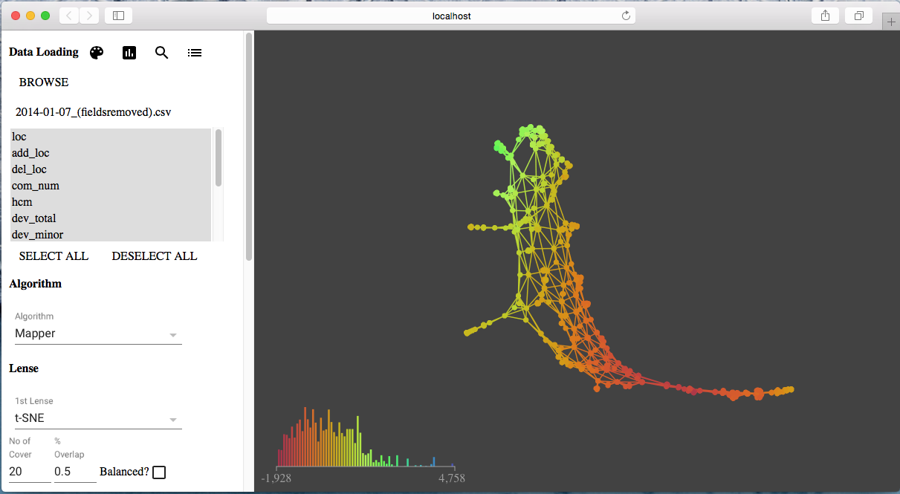

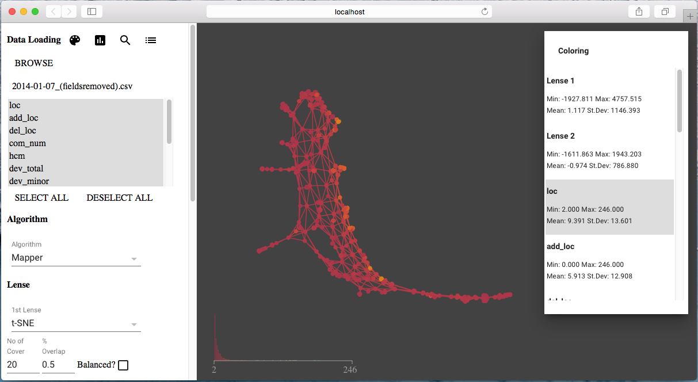

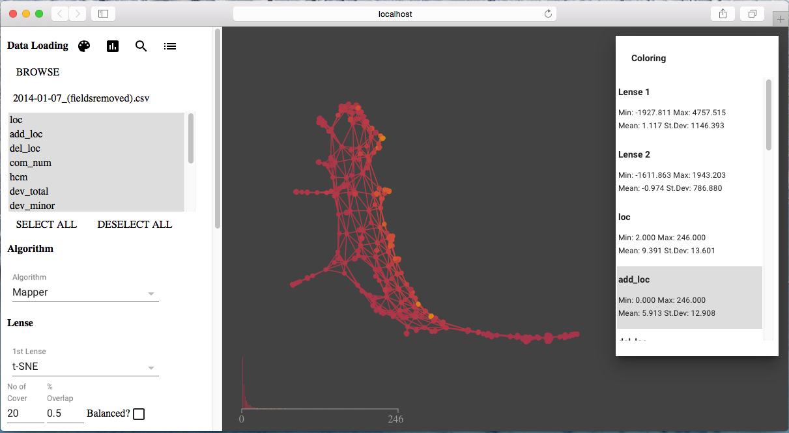

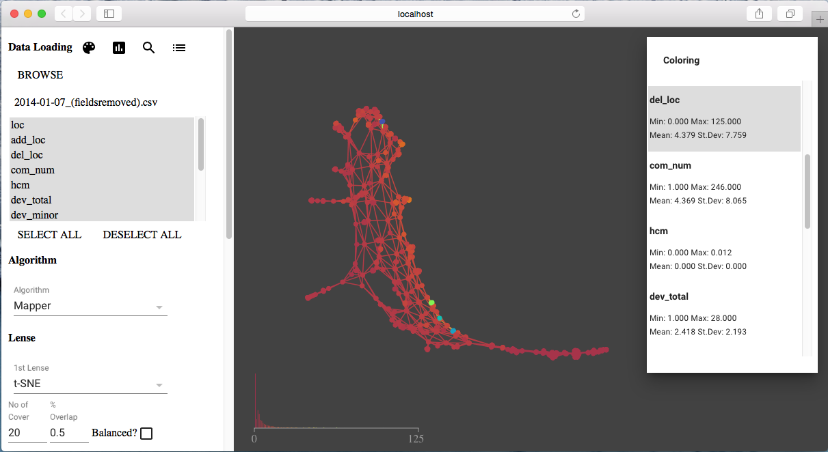

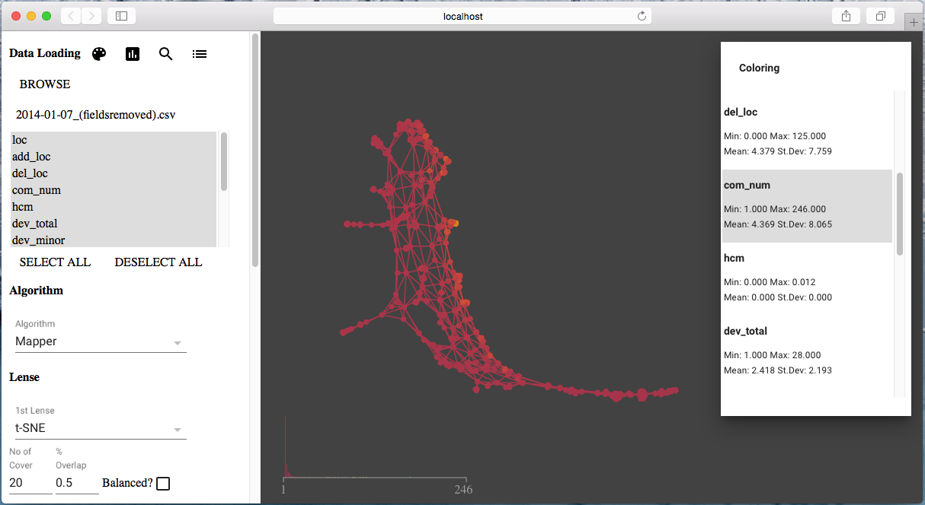

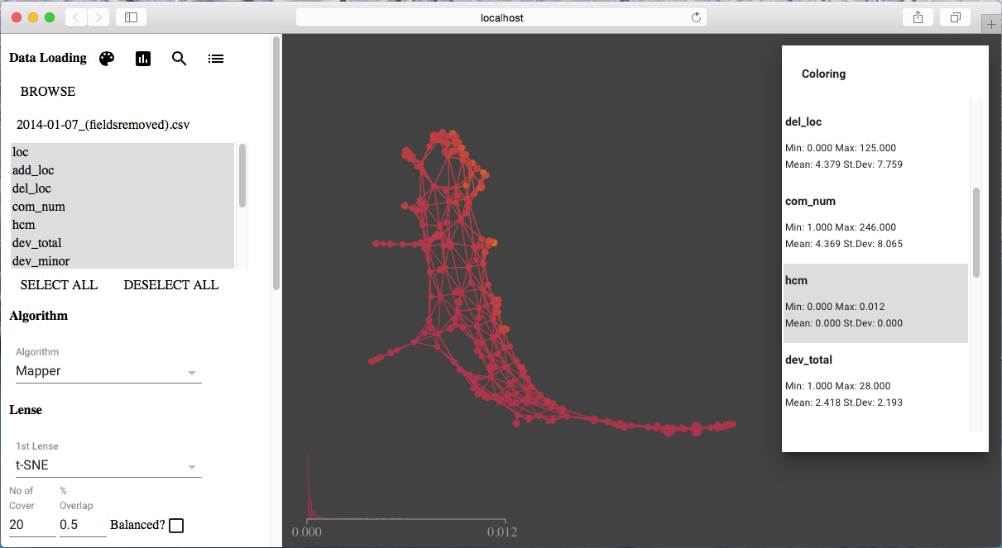

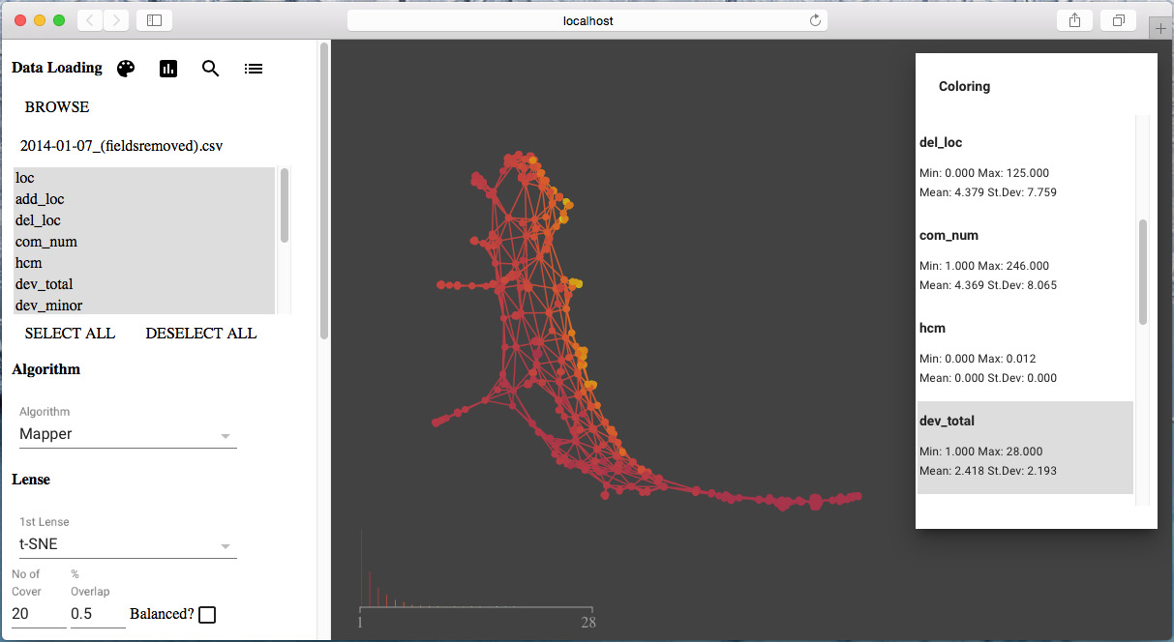

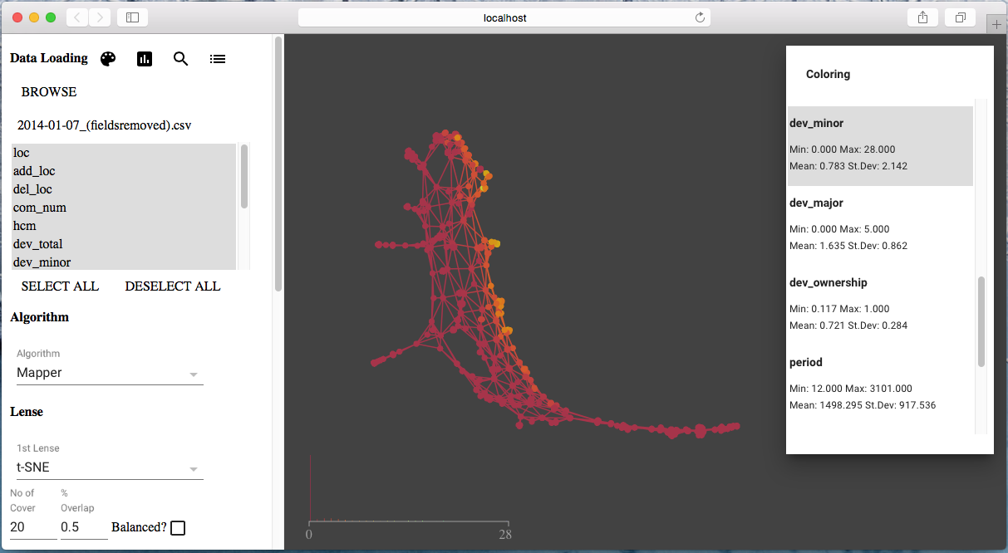

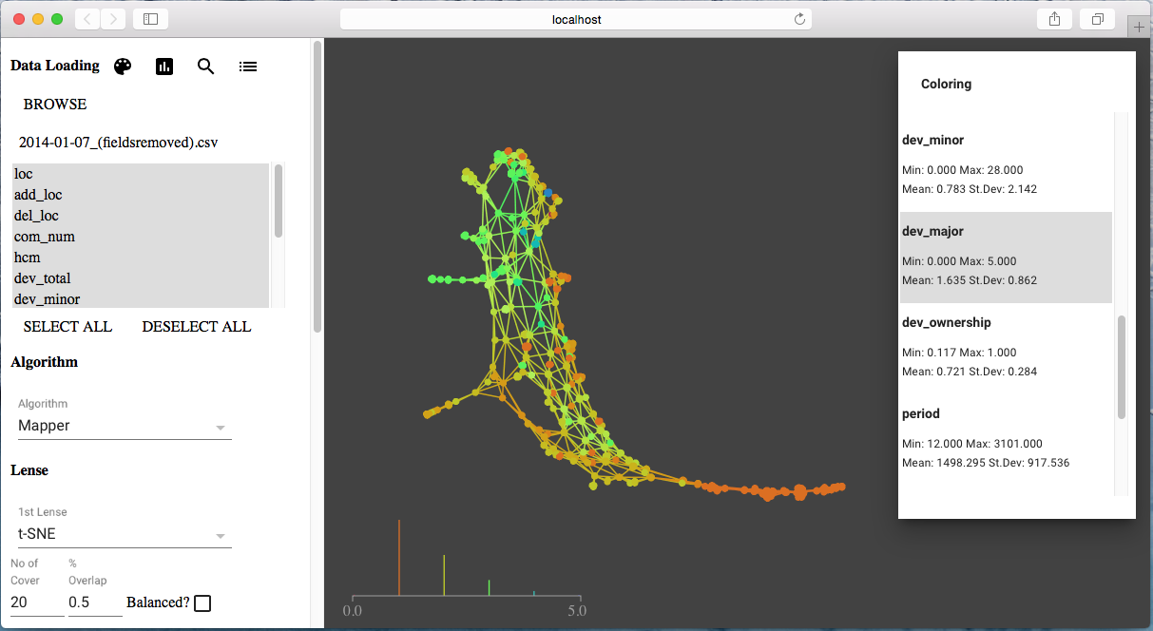

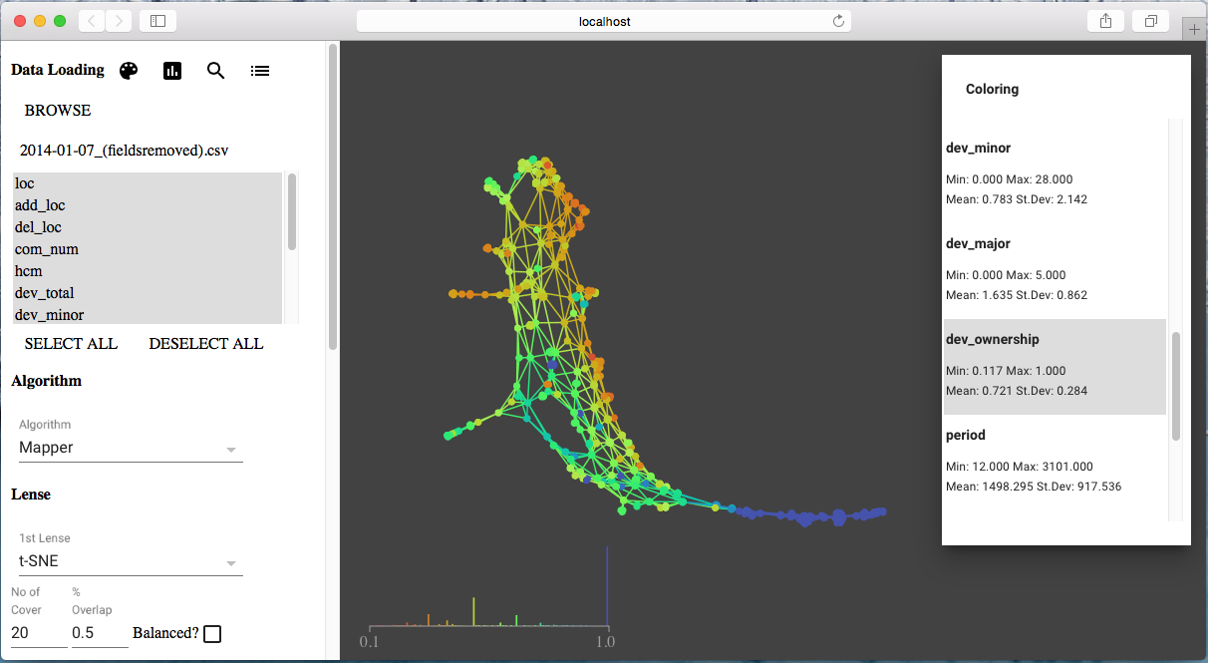

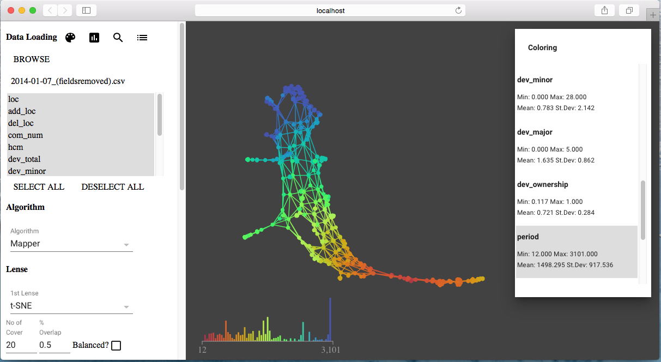

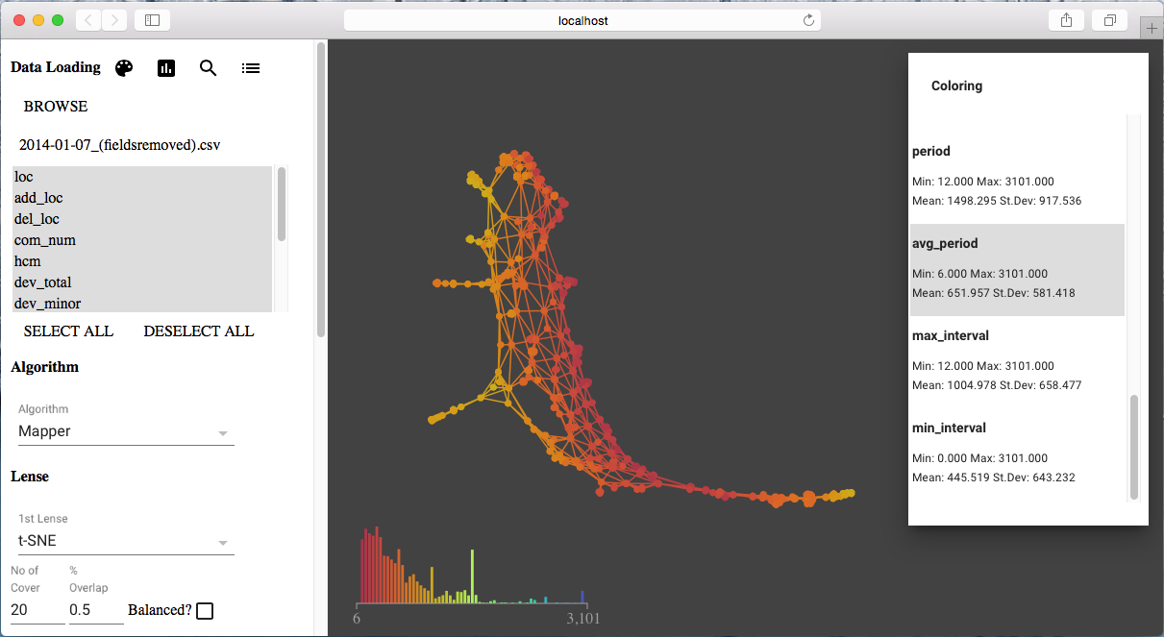

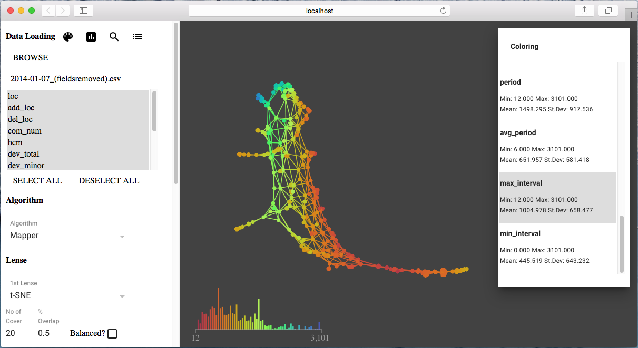

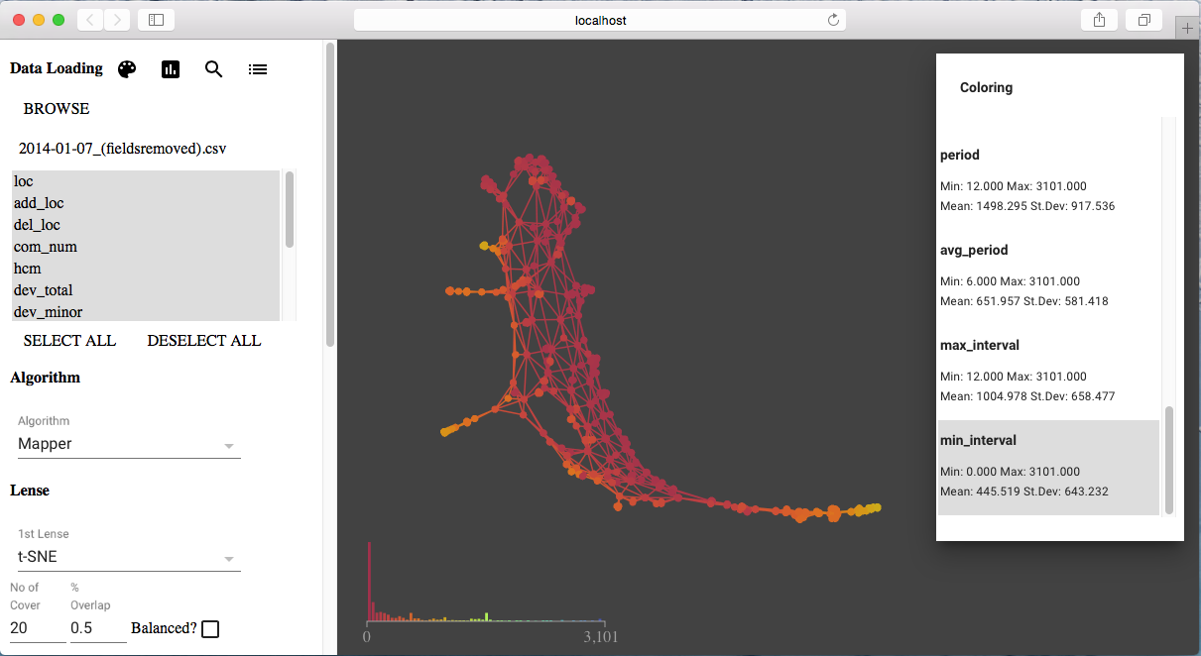

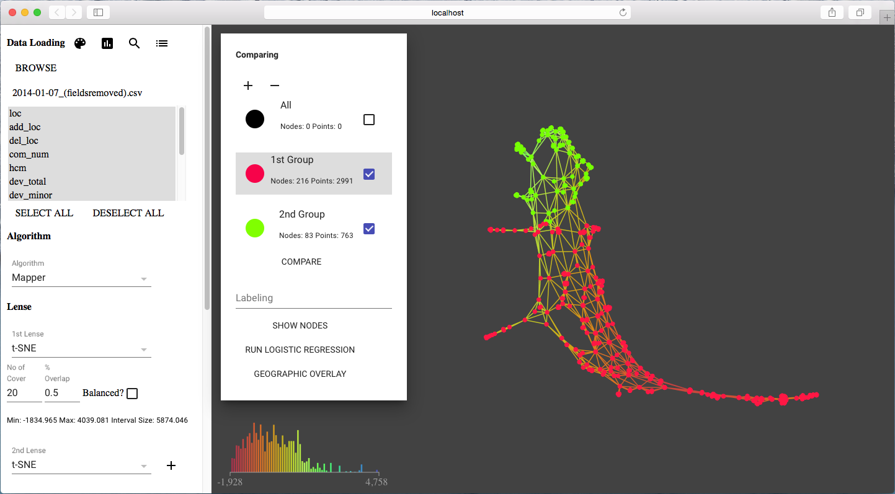

#### Analysis Result

|  |  |  |  |  |  |  |  |  |
| --- | --- | --- | --- | --- | --- | --- | --- | --- |
| **Variables** | **Group 1 min** | **Group 2 min** | **Group 1 mean** | **Group 2 mean** | **Group 1 median** | **Group 2 median** | **Group 1 max** | **Group 2 max** |
| loc | 2.0 | 2.0 | 9.064 | 13.114 | 6.0 | 6.0 | 106.0 | 246.0 |
| add_loc | 0.0 | 0.0 | 5.516 | 12.326 | 3.0 | 6.0 | 95.0 | 246.0 |
| del_loc | 0.0 | 0.0 | 4.457 | 8.048 | 2.0 | 5.0 | 106.0 | 125.0 |
| com_num | 1.0 | 3.0 | 3.665 | 10.341 | 2.0 | 7.0 | 74.0 | 246.0 |
| hcm | 0.0 | 0.0 | 0.0 | 0.001 | 0.0 | 0.001 | 0.002 | 0.012 |
| dev_total | 1.0 | 1.0 | 2.171 | 4.866 | 2.0 | 4.0 | 16.0 | 28.0 |
| dev_minor | 0.0 | 0.0 | 0.51 | 2.679 | 0.0 | 2.0 | 15.0 | 28.0 |
| dev_major | 0.0 | 0.0 | 1.661 | 2.187 | 1.0 | 2.0 | 5.0 | 5.0 |
| dev_ownership | 0.167 | 0.117 | 0.733 | 0.422 | 0.75 | 0.4 | 1.0 | 1.0 |
| period | 12.0 | 2121.0 | 1072.096 | 2867.093 | 1008.0 | 3038.0 | 2830.0 | 3101.0 |
| avg_period | 6.0 | 12.0 | 418.519 | 483.035 | 363.0 | 438.0 | 1067.0 | 1033.0 |
| max_interval | 12.0 | 166.0 | 718.31 | 1336.59 | 636.0 | 1238.0 | 2373.0 | 2877.0 |
| min_interval | 0.0 | 0.0 | 235.907 | 55.667 | 93.0 | 5.0 | 1067.0 | 980.0 |